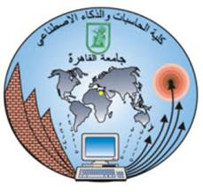Cairo University  
Faculty of Computers and Artificial Intelligence

Personal Budgeting

|  |  |  |
| --- | --- | --- |
| **Name** | **Email** | **Mobile** |
| Ahmed Hussein ahmed | 20230015@stud.fci-cu.edu.eg | 01066858421 |
| Menna AbdELGawad Fathi | 20230423@stud.fci-cu.edu.eg | 01124887979 |
| Mawada Emad Abdo Omar | 20230527@stud.fci-cu.edu.eg | 01114559585 |
| Fatema Elzhraa Ahmed Elfiky | 20230280@stud.fci-cu.edu.eg | 01221990828 |
| Malak Mohamed refaat | 20240831@stud.fci-cu.edu.eg | 01154150501 |

April of 2025

**Problem Selection:**

National FinTech Problem Statements 2019 -> Financial Literacy:

Millennials lack knowledge the importance of personal management. How can we educate them about personal financial management and long term investment?

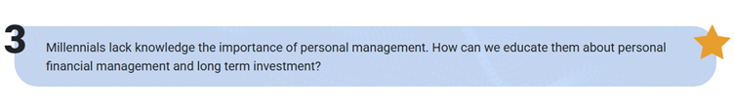

Contents

**1.Insights** 3

**Global Practices** 3

**1. USA: You Need A Budget (YNAB):** 3

**2. Singapore: MoeySense (Government initiative):** 4

**3. UK: MyMoneySense by NatWest :** 5

**Local Practices** 6

**Some Example:** 6

**Comparative Analysis:** 6

**2. SWOT and GAP Analysis:** 7

**2.1 SWOT Analysis** 7

**Strengths** 7

**Weaknesses:** 8

**Opportunities:** 8

**Threats:** 9

**2.2 GAP Analysis:** 10

**Gaps in Egypt:** 10

**Global Solutions:** 10

**3.Target Customer(Segmentation):** 11

*1) Customer Segments* 11

2)Demographics: 12

**4.Solution Details** 12

**1)Proposition:** 12

2) Benefits 14

3) Challenges 15

**1.Insights**

Many countries and people have faced the same challenge, and using a personal budget was the smart and simple way to improve their financial life.

With the rise in prices and the growing daily needs, understanding and managing a personal budget is no longer a choice it’s a must. A personal budget helps people control their spending, save for the future, and stay ready for any financial challenge. Learning how to track income and expenses is the first step to achieving dreams, avoiding debt, and living with financial peace of mind.

**Global Practices**

**1. USA: You Need A Budget (YNAB):**

first started in 2004 as a free Excel tool. By 2015, it evolved into a global budgeting application, now used by more than **4 million users** worldwide.

**Why it's popular?**  
YNAB is a simple and user-friendly app that helps people track their budget and save money. Its success is due to:

* Ease of use.
* Support from financial education programs and institutions.
* Focus on user goals and clear financial planning.

The app starts with a few easy questions:

* Do you have debts?
* What is your dream?
* How old are you?

These questions help build a personal budget plan and motivate users to control their expenses.

Link: <https://app.ynab.com>

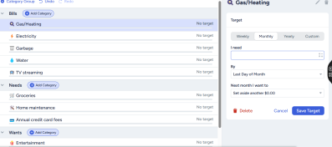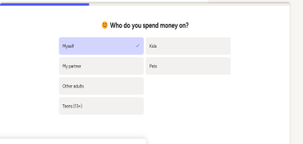 Questions To Make Page For users: control their expenses:

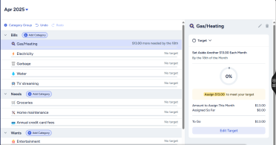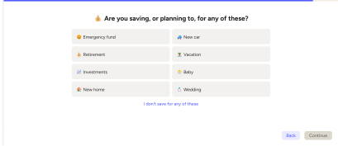

**2. Singapore: MoeySense (Government initiative):**

MoneySense is a national program launched by the Singapore government in 2003 to help people manage their money better. The goal is to make financial knowledge simple and available for everyone.

**Why it’s special?**

* It offers free tools, guides, and tips on saving, budgeting, and investing.
* It helps users plan for daily expenses, future goals, and even retirement.
* The program also runs workshops and online courses for all age groups.

MoneySense has made financial education a part of daily life in Singapore. Thanks to this program, more people have learned how to make smarter money choices and avoid debt

Link: <https://www.moneysense.gov.sg>

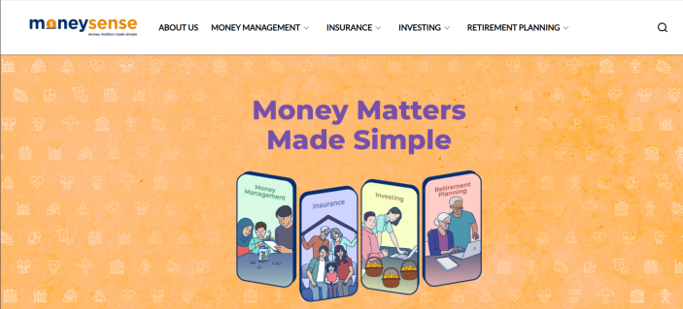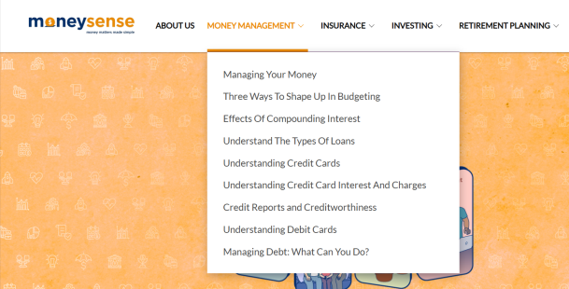The main page: Simple navigation bar and a lot of choices:

Explanations: Simple explanations:

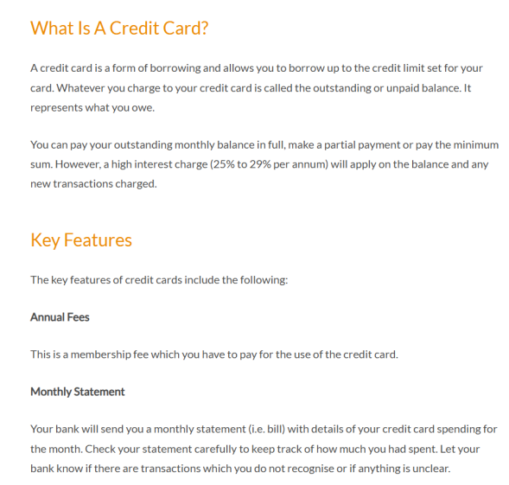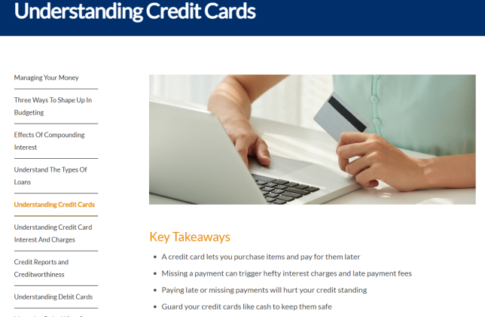

**3. UK: MyMoneySense by NatWest :**

MyMoneySense is an easy-to-use website, known for its **simplicity and attractive design**.  
This bank-led initiative offers **interactive tools, helpful articles, and fun learning modules** created especially for both individuals and schools.

The platform focuses on:

* Teaching basic money management skills.
* Helping users create and follow a personal budget.
* Making financial education simple and fun through games and real-life scenarios.

This approach encourages young people and adults to build strong financial habits early and apply them confidently in their daily lives

**Links:** [**https://natwest.mymoneysense.com**](https://natwest.mymoneysense.com)

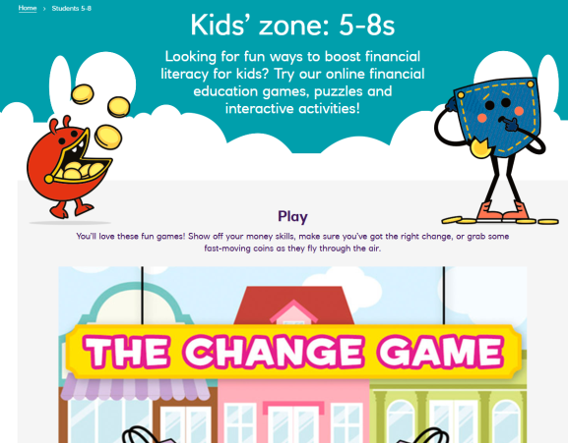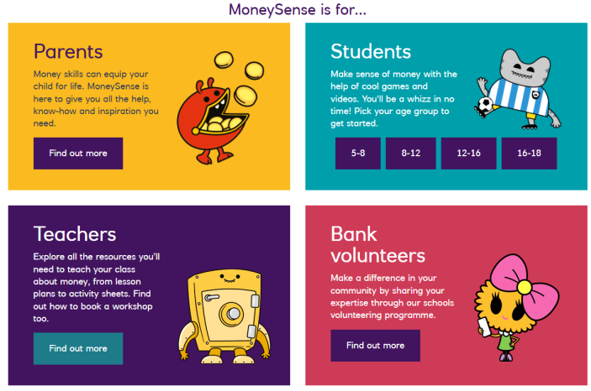**Attractive and easy design**: Games For children :

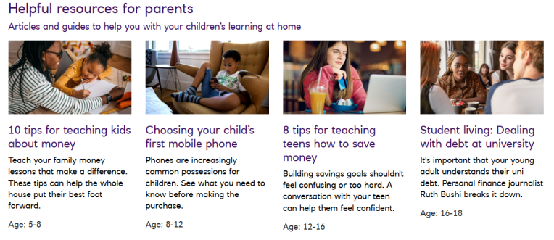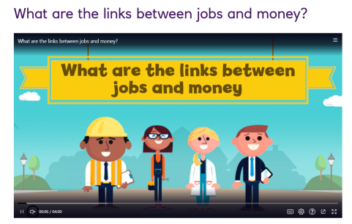Articles for parents: Educational videos for children:

**Local Practices**

In Egypt, the culture of personal budgeting is still not very strong or widespread. Some apps and programs offer simple tools for managing money)like telda ,masary) ,but they are not as advanced or popular as the global solutions like YNAB or MoneySense.

Most people depend on traditional ways like personal notes or mental tracking to manage their spending, and there is still a big need for more awareness and easy-to-use digital tools to help individuals plan their budget and save for the future.

**Some Example:**

**1.Masary**  
Masary is a digital wallet and payment platform that helps users manage their daily transactions, pay bills, and control spending — but it focuses more on payments rather than full personal budgeting.

2.**Fawry**  
Fawry is one of Egypt’s biggest electronic payment platforms. It allows users to pay bills, recharge mobile balance, and track transactions, but it does not offer advanced budget planning tools.

3.**Telda**  
Telda is a fintech app that allows users to send, receive, and spend money with more control. It gives a simple overview of spending habits, helping users become more aware of their financial behavior.

**Comparative Analysis:**

When we compare personal budgeting in Egypt to other countries around the world, we find that Egypt still lacks awareness and access to modern personal budgeting tools and technologies. Most people in Egypt prefer to use traditional ways like **pen and paper** or just **mental calculations**, which are old methods and not effective at all.

On the other hand, many other countries have created strong programs to support personal budgeting. For example, in the **UK**, there is a website designed for children to teach them how to manage their personal budget in a simple and fun way using games and easy videos. Parents also receive guidance on how to teach their children about saving, spending, and financial planning. The strong point here is that the government supports this learning and schools help students understand the importance of personal budgeting, which makes them more aware from a young age.

In another example, countries like **Singapore** created government websites that guide people and teach them important financial skills, including personal budgeting. These websites also offer free documents, tools, and useful resources to help users improve their financial life.

Some countries also provide **mobile apps** that help people manage their personal budget, reduce debt, save money, and plan for future goals. These apps offer easy tools and useful features to make budgeting simple and effective.

In Egypt, there is a strong need to raise financial awareness and change people's mindset about money. Personal budgeting can help people reach their goals, avoid debt, and build a better financial future.

**2. SWOT and GAP Analysis:**

**2.1 SWOT Analysis**

**Strengths**

**1. Visibility and Tracking:**  
Personal budgeting gives you clear control and understanding of your money. Unlike random spending, budgeting helps you track where your money goes. This makes it easier to make smart spending decisions and avoid surprises. It builds a more organized and responsible financial life.

**2. Goal Achievement:**  
Budgeting helps people reach their financial goals. Without a plan, money often disappears without any real progress. A clear budget helps you save for both short-term and long-term goals like buying a car, traveling, or starting a business. It gives your money a clear direction.

**3. Customizability:**  
Budgeting is flexible. It can fit your income, lifestyle, and future plans. Whether you are a student, a young worker, or a family person you can build a budget that matches your needs. And you can always adjust it when your situation changes.

**4. Financial Discipline:**  
A budget teaches you self-control and smart decision-making. Over time, it helps you avoid random or emotional spending and encourages you to use your money wisely. This habit makes your financial future stronger and more stable.

**5. Emergency Preparedness:**  
A good budget helps you save for emergencies. When unexpected things happen like car repairs, medical bills, or job loss you will be ready. This makes financial problems easier to handle and gives you peace of mind.

**Weaknesses:**

**1. Lack of Financial Awareness:**  
Many people don’t fully understand the value of personal budgeting. They might think budgeting is difficult or unnecessary, which causes them to waste money or live paycheck to paycheck.

**2. Limited Use of Technology:**  
In Egypt, personal budgeting apps or digital tools are not widely used. Most people still depend on pen and paper or mental notes, which makes it hard to track and manage money effectively.

**3. Cultural Habits:**  
Some people are not used to planning their expenses or setting financial goals. This habit leads to random and emotional spending without thinking about the future.

**4. Income Instability:**  
For people with unstable or low income, making a budget can be difficult, as their money often goes to cover basic needs, leaving little room for savings or planning.

**Opportunities:**

1. **Financial Education:**  
Budgeting gives a great chance to improve financial knowledge. It teaches people how to manage their money better, which helps with smarter financial decisions in the long run.

2. **Technology Integration:**  
With the growth of fintech, budgeting tools can become much easier and more efficient. Features like automation and AI can make budgeting faster and more accurate, which fits well with Egypt’s digital transformation plans.

3. **Life Planning:**  
Budgeting can go beyond money management. It helps link spending to life goals and personal values, leading to better decision-making and more purposeful living.

4. **Partnership with Banks:**  
Apps can work together with banks to offer special services — like automatic saving plans, financial advice, or discounts for users.

5. **Growing Digital Payment Systems:**  
As more people use digital wallets and online banking, personal budgeting apps can connect with these systems to give users a full view of their spending.

6. **Government Support:**  
If governments support financial education, they might recommend personal budgeting apps to schools and families, which will increase users.

**Threats:**

**1. External Economic Factors:**  
Personal budgets are vulnerable to broader economic conditions like inflation, economic downturns, and market volatility. These factors can disrupt well-designed budgets and require flexibility and contingency planning to remain effective during economic uncertainties.

2. **Income Instability:**  
Modern work patterns, including gig economy jobs and commission-based pay, create income volatility. This unpredictability can make it harder to apply traditional budgeting methods, which assume a stable, monthly income.

3. **Lifestyle Inflation:**  
As income increases, so do social and cultural pressures to increase consumption. This phenomenon, known as lifestyle inflation, can undermine budgeting success. Even with higher earnings, failing to maintain disciplined spending habits can hinder financial growth.

4. **Technological Vulnerabilities:**  
While digital budgeting tools offer convenience, they also introduce cybersecurity and data privacy risks. Financial data stored in apps can attract hackers, and concerns about how providers handle user data may reduce trust in these tools.

5. **Family Dynamics:**  
Budgeting within households can face challenges due to differing financial priorities and attitudes. Disagreements about spending, saving, and financial goals among family members can create tension, complicating the budgeting process and hindering its success

We can summarize all this point in this:

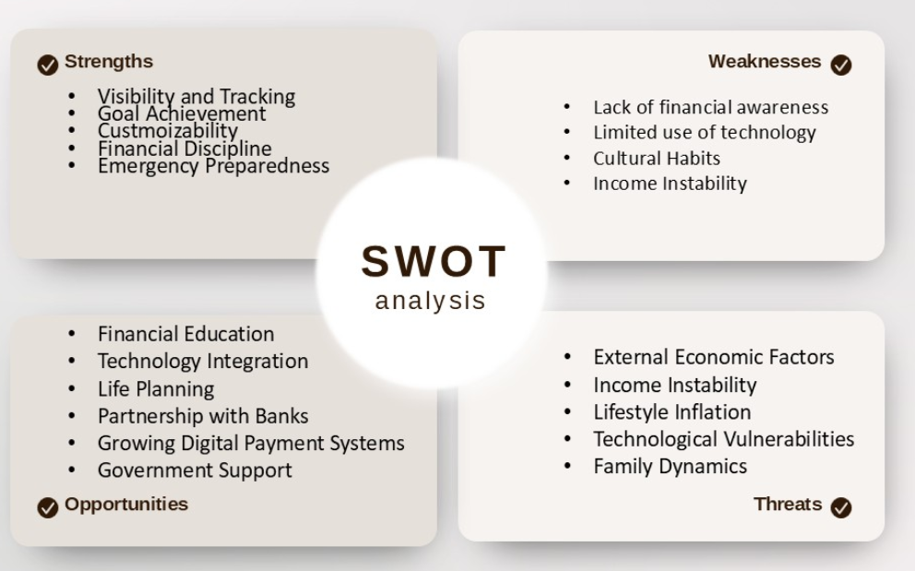

**2.2 GAP Analysis:**

There is a clear gap in the market in the lack of awareness of personal budgeting software among users, especially in Egypt and Arab countries, compared to foreign countries. Although financial planning has become a necessity with the rising cost of living, many individuals do not realize the importance of these tools or how to benefit from them.

**Gaps in Egypt:**

|  |  |  |
| --- | --- | --- |
| **Major Problem** | **Gap** | **Opportunity for Innovation** |
| Lack of Financial Awareness and Literacy. | In Egypt, awareness programs about personal budgeting are limited and not accessible to all social classes. | Develop financial education programs for schools, universities, and online platforms to embed financial skills early in life. |
| Lack of Financial Data Integration. | Most apps in Egypt lack integration with local banks, forcing users to manually input data, risking errors. | Create applications integrated with Egyptian banks and e-wallets for real-time data updates and enhanced user convenience. |
| Lack of Intelligent Spending Analysis. | Existing tools only record expenses without offering insights or recommendations for improving financial health. | Incorporate AI-driven analysis and reporting that provides users with actionable financial advice and goal tracking. |
| Lack of Awareness About Saving and Investing. | Users tend to focus on daily expense management rather than long-term wealth building through savings and investments. | Develop apps or platforms that guide users in saving and investing smartly, introducing them to stocks, funds, and local opportunities. |

**Global Solutions:**

|  |  |
| --- | --- |
| **Gap in Global Solutions** | **Opportunity for Innovation** |
| Foreign apps do not support Egyptian wallets or local banks, and often use a language that is difficult for many Egyptians. | Create a user-friendly, fully localized Egyptian budgeting app that supports Egyptian banks and e-wallets, and offers clear Arabic language. |
| Complex technology and too many unnecessary features that overwhelm average users. | Develop a simple, intuitive Egyptian budgeting app with only essential features, designed for everyday use by all income groups. |

**3.Target Customer(Segmentation):**

## **1) Customer Segments**

1. Unbanked Young Adults  
Young adults (aged 18-30) who do not have formal banking relationships and rely mainly on cash for transactions.  
This segment represents a strong opportunity for financial inclusion, as they seek simple and affordable solutions to manage daily expenses and save for short-term goals.

2. Financially Stretched Middle Class  
Middle-class individuals and families who struggle to balance their income with increasing living expenses.  
This segment needs easy-to-use tools for tracking expenses, identifying saving opportunities, reducing debt, and building emergency funds.

3. Micro and Small Entrepreneurs  
Small business owners who often mix personal and business finances, which affects the growth and sustainability of their ventures.  
They require solutions to monitor revenues, expenses, and make more informed financial decisions for their businesses.

4. Digital-First Gen Z  
Young people raised in the digital era who expect financial services to match their fast-paced, connected lifestyle.  
They prefer instant, engaging, user-friendly applications, ideally with social features, gamification, and competitive elements.

5. Financial Dependents in Transition  
Students and recent graduates who are shifting from financial dependence on family to self-management.  
They seek tools to build basic financial habits, avoid common financial pitfalls, and start establishing a healthy credit history.

2)Demographics:

|  |  |
| --- | --- |
| Attribute | Details |
| Age Range | 18 – 40 |
| Income | 300-1000EGP/monthly |
| Education | moderate to high educational levels |
| Location | Egypt |
| Occupation |  |
| Technology | Smartphone and financial app users, but not deep financial software  experience. |

**4.Solution Details**

**1)Proposition:**

To increase awareness about financial budgeting, we need to develop an app that helps people manage their personal budgets. The app should be easy to use and user-friendly. We can also add a document section that provides information about major financial concepts, like the examples used in Singapore. This feature will help people learn more about finance and raise their financial awareness.

**A. Purpose and Goals**

**1. Start Budgeting**

• The essential purpose of a budget is to ensure you live within your means while setting aside money for future expenses.

• Budgeting doesn’t require strict spreadsheets, start by subtracting average expenses from income. For stricter control, allocate fixed amounts to categories (e.g., groceries, rent).

• Example: The average family of four spends **$7,095/month** on essentials (housing, food, bills). Track your own spending for **3 months** to build a realistic budget.

**2. Build Your Savings**

• Savings prepare you for emergencies (medical bills, car repairs) and future goals (home, vacation).  
• **Short-term goals** (e.g., vacation): Save monthly for **6–12 months**.  
• **Long-term goals** (e.g., home down payment): Use high-yield accounts or investments.  
• **You can** Automate transfers to a separate savings account to stay disciplined.

**3. Improve Your Credit**

• A strong credit score unlocks better loan rates and approval chances.  
• **How to build credit:**

* Pay bills **on time**
* Pay off debts.
* Keep credit card balances **low**.
* Avoid opening too many lines of credit
* Check your reports regularly

**B. Key Features and Functionality**

**1. Income & Expense Tracking**

• Log transactions manually or **sync bank accounts** for automatic tracking.  
• **AI categorization**: Labels spending ("Food," "Utilities" ,..etc).

**2. Budget Creation**

• Set **monthly limits** per category (e.g., $500 for groceries).  
• **Alerts** when nearing budget caps.

**3. Goal Setting**

• Create goals.  
• **Progress bars** visualize savings growth.

**4. Reports & Insights**

* **Spending trends**: Charts and graphs show where money goes ("You spend 40% on rent").
* Provide **insights** into spending patterns
* **Give suggestions**: "You should reduce dining out to once a week."

**5. Bank Integrations**

• Secure APIs (**Plaid/Yodlee**) sync banks, e-wallets (e.g., **Vodafone Cash**), and credit cards.

**6. User-Friendly Design**

• **Mobile app (Flutter) + web (React.js)** for easy access.  
• **Simple UI**: Color-coded budgets, one-click reports.

**7. Question and answer section**:

* That feature would be able to let the Egyptians to ask about any question related to the finance and there will be a chatbot answer to their questions.

**8. Tutorial section:**

* You will be able to learn more about finance. It will be supported by the CBE to increase the awareness of finance in Egypt like in **Singapore**.
* There will also be interactive and motivational activities, along with questions to answer, to encourage financial awareness. Participants will collect points that can later be exchanged for gifts.

**9. AI Automated plans:**

* It will suggest for you a plan to follow to manage your personal budget according to your answers of the questions that will be asked iteratively about your financial circumstances and your priorities.

**C. Target Users**

**1. Individuals**

• Manage daily spending and debt repayment.

**2. Youth (18–30)**

• Save for travel, education, or starting a business.

**3. Freelancers & Entrepreneurs**

• Handle **irregular income** and separate business/personal finances.

**4. Head of the family**

**D. Technologies**

**1. Frontend**

• **Web**: React.js/Angular for responsive dashboards.  
• **Mobile**: Flutter (ios/Android).

**2. Backend**

• **Framework**: Node.js/Express.js or Django.  
• **Database**: PostgreSQL (secure transaction storage).

**3. APIs**

• **Banking**: Plaid/Yodlee.  
• **Payments**: PayPal/InstaPay (Egypt).

**4. Hosting**

• **Cloud**: AWS/Google Cloud for scalability.

**5. Security**

• **Auth**: OAuth 2.0 + biometric login.  
• **Encryption**: AES-256 for sensitive data.

**6. AI : Chat bot** and **Automated AI**

## 2) Benefits

**1. Financial Inclusion**  
The app empowers underserved populations, including youth and low-income segments, to actively manage their finances, thereby increasing their engagement with the formal financial system.

**2. Encourages Saving and Responsible Spending**  
Through goal tracking and budgeting features, users are encouraged to adopt better financial habits, reduce unnecessary spending, and improve their long-term financial resilience.

**3. Increased Financial Literacy**  
The app integrates educational content and visual analytics, helping users better understand essential financial concepts such as interest, debt management, and long-term planning.

**4. Cost Reduction for Financial Institutions**  
By encouraging self-service and reducing financial mismanagement, the app can help lower loan defaults and facilitate more accurate customer risk assessments for financial institutions.

**5. Improves Accessibility to Financial Planning Tools**  
With its mobile-first design, the app ensures that users from various geographic and economic backgrounds can access advanced budgeting features at little to no cost.

**6. Supports National Digital Transformation Goals**  
The solution aligns with Egypt’s financial inclusion strategy and Vision 2030 goals, aiming to expand digital services to underserved communities.

## 3) Challenges

**1. User Adoption and Digital Literacy Gaps**  
A significant portion of the target market may lack the necessary digital skills or financial confidence to use budgeting tools effectively, requiring dedicated user education campaigns.

**2. Regulatory and Compliance Barriers**  
Integration with financial institutions and handling personal financial data must comply with local regulations, including data protection laws and Central Bank requirements, to avoid legal and operational challenges.

**3. Cybersecurity and Privacy Risks**  
Storing and processing sensitive user data presents risks of breaches or misuse. Ensuring strong encryption and transparent data handling policies will be essential for protecting users' privacy.

**4. Trust and Cultural Barriers**  
Some users may be hesitant to trust digital apps with their financial information, particularly in societies where cash transactions dominate, requiring trust-building efforts and cultural awareness.

**5. Integration with Financial Institutions**  
Achieving seamless integration with various banks and mobile wallets requires standardized APIs and cooperation from financial service providers, which may be challenging in a market with diverse technical infrastructures.

**6. Sustainability and Monetization**  
Without careful planning, the business model may become too dependent on freemium features or ads, which could compromise the user experience or app quality over time. A balanced approach between providing value to users and generating revenue will be critical for long-term success

**Communication/Marketing Plan**

**Messaging:**

* Take **control** of your financial life!  
  Our app helps you track your **expenses**, **save money** smarter, and **achieve** your financial **dreams** easily.
* Easily track and manage your daily expenses in just a few taps.
* Your money, your rules. Budget smarter with us.
* Now you can live without fear of debt we are here to help you manage your finances smarter!
* Our app supports both Arabic and English, so language will never be an obstacle for you.
* No bank **account**? No problem! Our app is made for **everyone**.

**Channels:**

Nowadays, the power of social media is enormous and provides great value for any product or service.  
Therefore, we will use it to reach our goal: by creating strong advertisements and showcasing the power of our app, we can increase our user base significantly.

**Influencers**: Influencers are very important for our marketing strategy.  
We plan to collaborate with popular influencers to promote our app, which will excite their audience and encourage them to try our platform.  
Additionally, we can create a competition between influencers, where each one shows how much they can save using our app.  
This approach will spread awareness of our app and motivate more users to join and achieve their savings goals.

**Partnerships**: We aim to build partnerships with several banks to make it easier for users to connect their accounts and manage their finances smoothly through our app.

### ****Campaign: Education and Rewards****

**Campaign Goal:**  
Our goal is to educate users on the importance of personal budget management and financial literacy. We will achieve this by providing a tutorial section within the app, which will include documents related to finance and personal budget management. Additionally, there will be a Q&A section where users can answer questions based on what they’ve learned. Correct answers will earn them points, which can later be redeemed for rewards such as restaurant vouchers or cash.

**How the Campaign Works:**

1. **Educational Tutorials:**  
   The campaign will feature an educational section in the app where users can access documents and resources related to personal finance and budgeting. Topics will cover how to create a personal budget, set financial goals, and save for emergencies.
2. **Q&A Section:**  
   After reading the educational content, users can test their knowledge by answering questions related to financial planning and budget management. Correct answers will earn them points.
3. **Rewards System:**  
   Users can accumulate points by correctly answering questions. These points can later be redeemed for rewards such as restaurant vouchers or even cash. The goal is to motivate users to learn the best practices of managing money and apply them in their lives.

**Benefits for Users:**

* **Practical Learning:** Gain useful knowledge on personal budget management.
* **Continuous Motivation:** Earn points by answering questions correctly.
* **Attractive Rewards:** Redeem points for real rewards like vouchers or cash.

SRS : [You will find it here](https://drive.google.com/file/d/1PBN77JpZ2AfwJFLC1X1qGnhpIbQc6H8M/view?usp=sharing)